Hi Sunny –

For this next chart, I would like to try and incorporate a time-lapse feature.

Amcharts provides us a few options to do so…

There’s a video version: <https://www.amcharts.com/demos/bar-chart-race/>

And then there are these versions that provide a scroll bar to provide a bit more control for the user:

https://www.amcharts.com/demos/day-and-night-world-map/

<https://www.amcharts.com/demos/corona-virus-animated-dashboard/>

<https://www.amcharts.com/demos/coronavirus-animated-dashboard-u-s/>

<https://www.amcharts.com/demos/countries-morphing-to-heart/>

<https://www.amcharts.com/demos/map-line-chart-gauge/>

All of these options may actually be the same thing. Perhaps the first chart example which is a video could also have a scroll bar but its instead disabled… I’m not sure.

But anyways… the purpose of this chart is to be an experiment to see if it will be superior to the previous line chart we just made.

I have created a new table to accommodate the data for this chart. The name of the table is “options_accuracy2”. You will see that this table contains many many more columns than the previous options_accuracy table.

Before explaining further, I think it’s important to provide some context on the original option accuracy table and graph… the current line graph compares/contrast the accuracy of predicting option values that expire in 7 days. The key takeaway here is that I arbitrarily picked 7 days as the period of time to graph. However, there is no reason why we couldn’t also graph a period of time either less than or greater than 7 days.

The new table accommodates for this… and includes line values for both csi and regular for expirations in the range for 3-30 (and all days in between). I understand this is many different days but I have a feeling the time lapse functionality of amcharts can capture this quite well.

As for the annotations feature… this can still be hard corded for each day and I have included a CSV file that contains the r^2 values for each expiration (“days out”).

To clarify a bit… the goal will be to use time lapse and each day’s graph will show:

1 – CSI Deltas

2 – Black Sholes Deltas

3 – Expected (data for this line will be the same exact thing for each day)

4 – Annotation (as provided in the CSV file)

5 – Days to Expiration

The last item on the list (Days to Expiration) is new but I have added it to the screenshot below to demonstrate (bottom right of the graph). The value will change for each day during the timelapse.

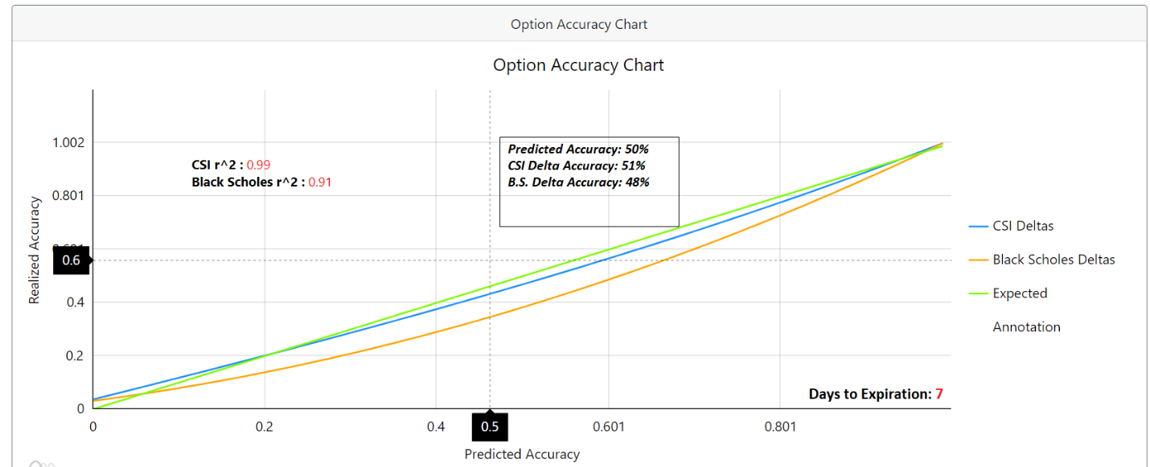

Scroll bar feature… most of the time lapse example from amcharts contain a scroll bar feature that the user can use to manipulate the chart. I am hoping to have that included as well, if possible.